The Castle

Ryan Coon

CYB-505

Professor Devin Ogg

September 11, 2024

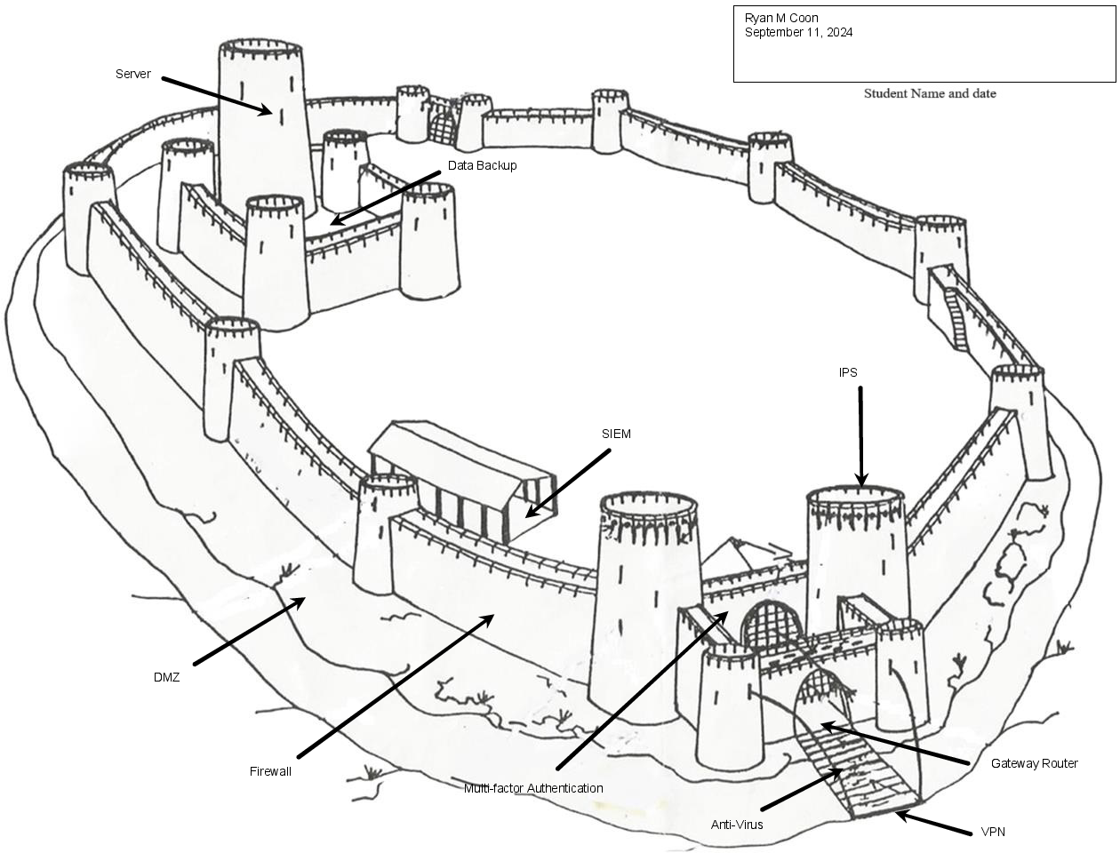

When considering a castle as a metaphor for cybersecurity, we can break down the defensive layers into both physical and technical aspects. Here’s how these aspects can be organized for each layer of defense, focusing on protecting the king (the leader) and the server (the critical data/infrastructure):

|  |  |  |
| --- | --- | --- |
| Layer | Physical Security Aspects | Technical Security Aspects |
| Outer Wall | * High Walls and moats to deter intruders * Guard towers for surveillance | * Firewalls to filter incoming and outgoing traffic * Intrusion detection systems |
| Inner Courtyard | * Secured gates with locks and guards * Controlled access points | * Network segmentation to limit access * Virtual Private Networks for secure communication |
| Keep (Main Building) | * Reinforced doors and secure locks * Security personnel for monitoring | * Encryption for data protection * Access controls and authentication measures |
| Throne Room | * Safe and secure environment for the “King” * Emergency exits to rapid evacuation | * Role Based Access Control for sensitive data * Security Information and Event Management |
| Server Room | * Restricted access to authorized personnel only * Surveillance cameras and alarm systems | * Anti-Virus and anti-malware software * Regular software updates and patch management |

The complexity of castles' construction and purposes necessitates a breakdown of this type of diagram. The gateway router functions as the entrance to the castle, serving as the point of connection between different transmission protocols and the first line of defense against attacks. The VPN acts as a deterrent and prevention method for attackers, akin to a drawbridge of a castle, by masking your network while browsing the web publicly. The firewall, similar to an outer wall of the castle, detects and controls traffic on your network, providing both deterrence and detection of threats. The IPS, like a guard tower, scans and prevents network vulnerabilities. The demilitarized zone serves as a defense against untrustworthy foreign data and is comparable to the moat surrounding the castle. Multi-Factor Authorization checks for two forms of credentials, similar to a gate guard asking for verification at the entrance. SIEM is a system that monitors, analyzes, and tracks events in real time on your system while logging data for audits and compliances. The server, akin to the castle itself, processes requests from a client and makes decisions for the system as a whole. Lastly, data backup involves duplicating data on the server to safeguard against data loss.

To effectively guard against cyber threats, a comprehensive understanding of cyber defense tools, methods, and components is essential. Here’s a detailed overview along with how to apply these methods to prepare a system for repelling attacks.

**Cyber Defense Tools**

Firewalls:

Block unauthorized access to or from a private network.

Configure rules to allow or deny traffic based on predefined security policies.

Intrusion Detection/Prevention Systems (IDS/IPS):

Monitor network traffic for suspicious activity and respond accordingly.

IDS alerts administrators, while IPS can take action to block threats automatically.

Antivirus and Anti-malware Software:

Detect and remove malicious software before it can cause damage.

Regularly update signatures to protect against the latest threats.

Security Information and Event Management (SIEM):

Collects and analyzes security data from across the organization.

Provides real-time analysis and alerts for unusual activities.

Encryption Tools:

Protect sensitive data both in transit and at rest.

Use protocols like SSL/TLS for secure communications.

Backup Solutions:

Regularly back up data to ensure recovery in the event of an attack.

Use both on-site and off-site backups for redundancy.

**Cyber Defense Methods**

Risk Assessment:

Identify and assess potential threats to the system.

Determine vulnerabilities and prioritize them based on impact and likelihood.

Access Control:

Implement role-based access controls (RBAC) to restrict access to sensitive information.

Use multi-factor authentication (MFA) to enhance user verification.

Regular Software Updates:

Keep operating systems, applications, and security tools up to date to protect against known vulnerabilities.

Automate updates where possible to ensure timely application.

User Education and Training:

Conduct regular training sessions to educate employees about security best practices and phishing attempts.

Foster a culture of security awareness within the organization.

Incident Response Planning:

Develop a comprehensive incident response plan outlining roles, responsibilities, and procedures for responding to security breaches.

Test the plan regularly to ensure effectiveness during an actual incident.

**Applying Cyber Defense Methods**

Conduct a Security Assessment:

Evaluate the existing security posture and identify weaknesses.

Implement a Multi-Layered Defense Strategy:

Utilize a combination of tools (firewalls, IDS/IPS, antivirus) to create multiple layers of security.

Ensure that both perimeter and internal defenses are in place.

Establish Strong Access Controls:

Enforce strict access policies and regularly review user access rights.

Use strong, unique passwords and enable MFA.

Regularly Update and Patch Systems:

Schedule periodic reviews and updates of all software and hardware components.

Monitor for emerging vulnerabilities and apply patches promptly.

Backup Data Regularly:

Implement automated backup systems and test recovery procedures to ensure data integrity.

Monitor and Analyze Security Events:

Use SIEM tools for real-time monitoring and analysis of security incidents.

Respond quickly to alerts to mitigate potential breaches.

Engage in Continuous Improvement:

Regularly assess and update security policies and practices based on new threats and vulnerabilities.

Conduct penetration testing to evaluate the effectiveness of the defense mechanisms.

By utilizing a combination of cyber defense tools, implementing robust defense methods, and preparing systems through structured approaches, organizations can significantly enhance their ability to repel cyber attacks and protect sensitive data. Continuous monitoring, updating, and user education will further strengthen the overall security posture.

References:

[2] Davis, Michael A., Time for a New Strategy, InformationWeek, Feb. 22, 2010, Cover and pp. 29-34, http://www.informationweek.com/news/security/management/showArticle.jhtml?articleID=223000132

Efthymiopoulos, M. P. (2019). A cyber-security framework for development, defense and innovation at NATO. *Journal of Innovation and Entrepreneurship*, *8*(1). https://doi.org/10.1186/s13731-019-0105-z

Jabr, F. (2021). John A. Long - Publications List. *Publicationslist.org*, *14*(6).

Saydjari, O. S. (2004). Cyber defense: art to science. Communications of the ACM, 47(3), 52-57. Bradley, T. (2021). What is a firewall and how does a firewall work? Retrieved from: https://www.lifewire.com/what-is-a-firewall-2487290.

*What is Defense in Depth | Benefits of Layered Security | Imperva*. (2023, December 20). Learning Center. https://www.imperva.com/learn/application-security/defense-in-depth/#:~:text=Data%20protection%20%E2%80%93%20Data%20protection